Sign up
Join 365 developer program https://developer.microsoft.com/en-us/office/dev-program

Join Now
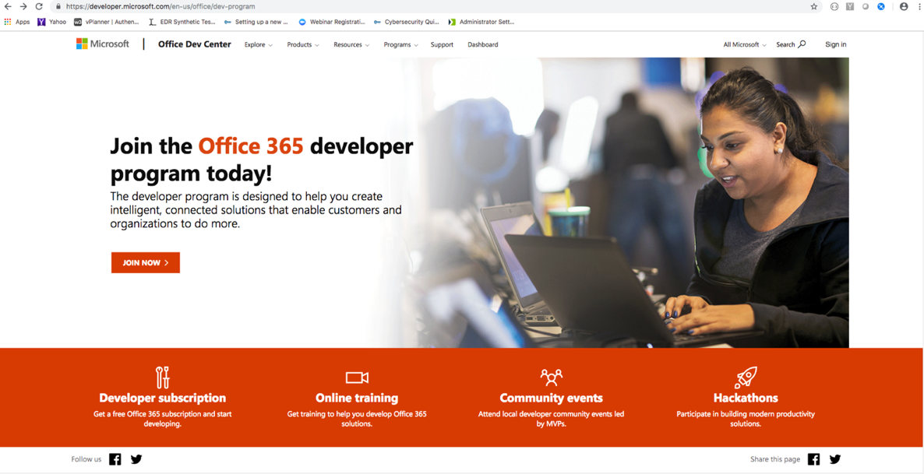

Sign in using your IBM intranet details
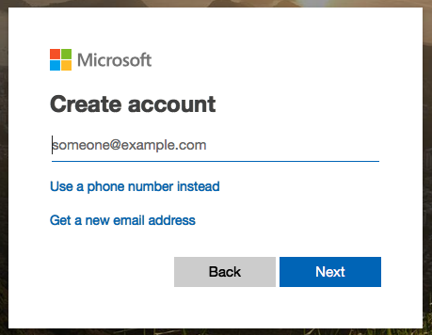

After entering your IBM ID above choose the “Work or School Account” option which takes
you to IBM’s W3 single sign on.

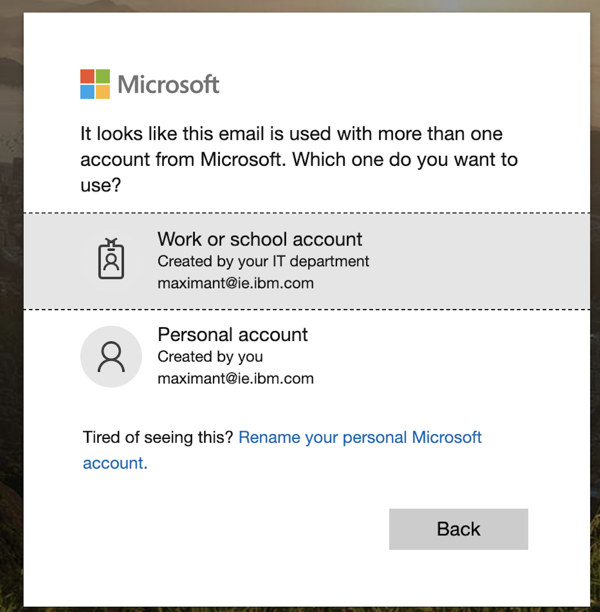

Click on Dashboard tab
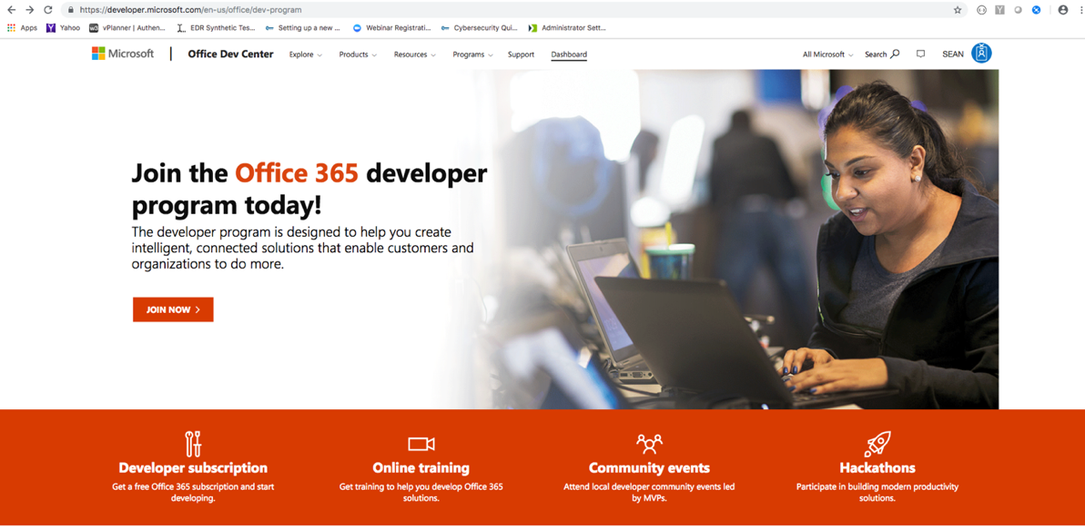

Screen shot below shows where I ended up after joining the dev program – different to yours above.
On this screen I clicked Dashboard, then “Set up subscription”
(don’t know if clicking Dashboard made any difference?)

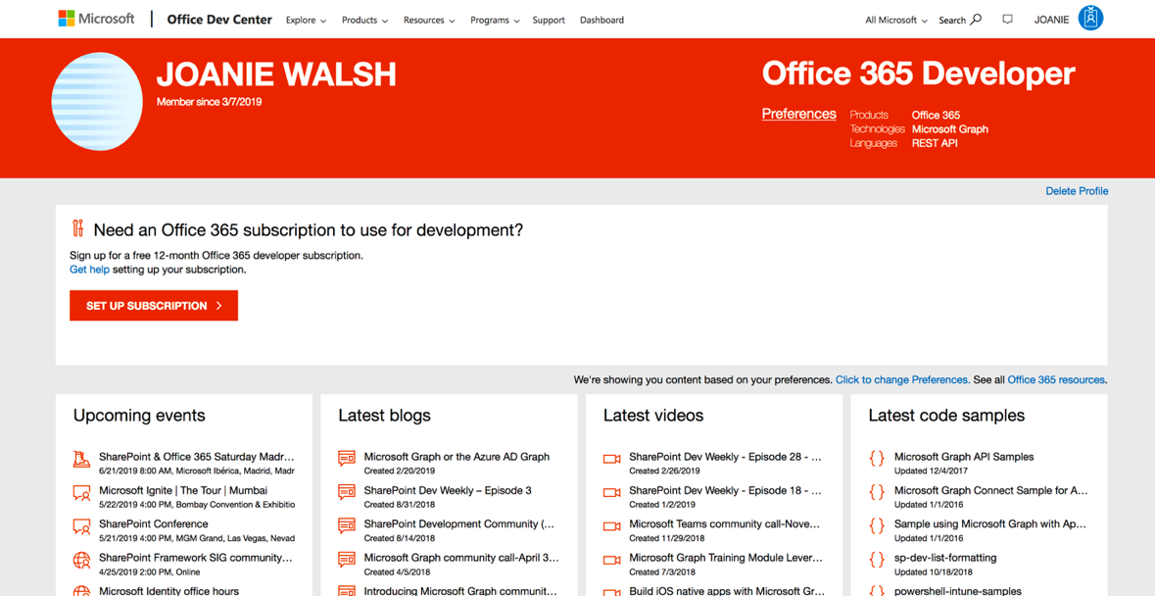

Define user name and domain
Might be worth mentioning that this username and domain should be specific to the developer program, not related to IBM credentials:
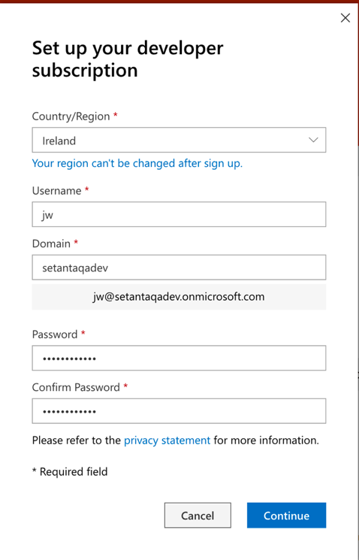

Suggest: In the next dialog box, specify a legitimate phone number. Phone number will be used by Microsoft to send you the subscription setup code.

On the Office 365 page, click Assign Products
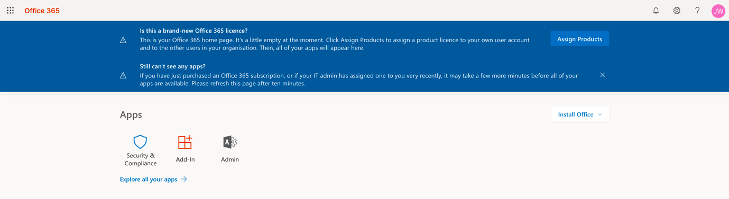

In the Microsoft 365 admin center, select your user.
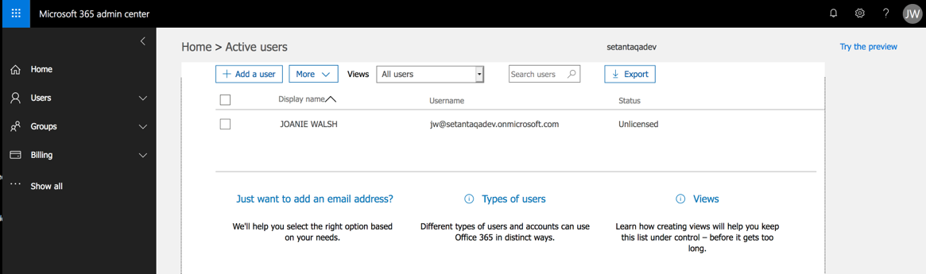

On your user profile page, assuming there are no products assigned yet, select Product licenses -> Edit.
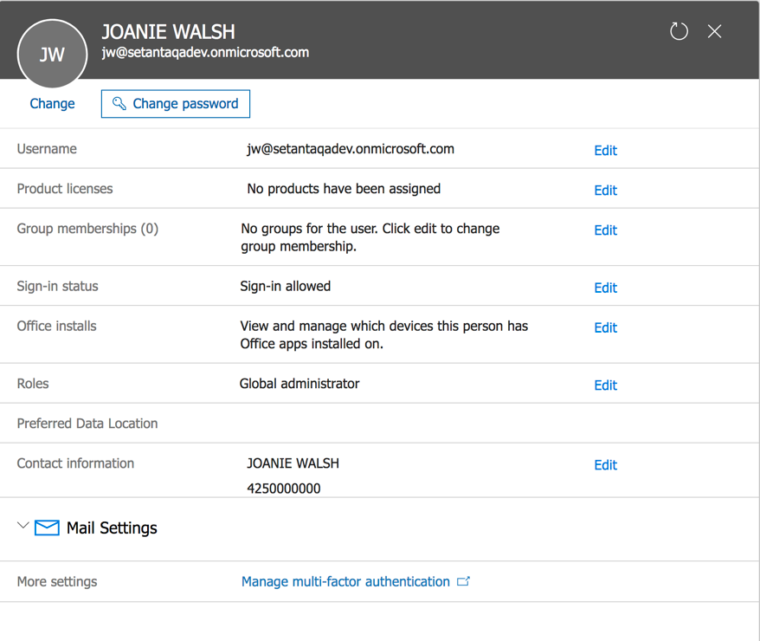

On the product licenses page, select your location, then turn Office 365 Enterprise E3 Developer “On”. (Sub-items are then automatically selected).
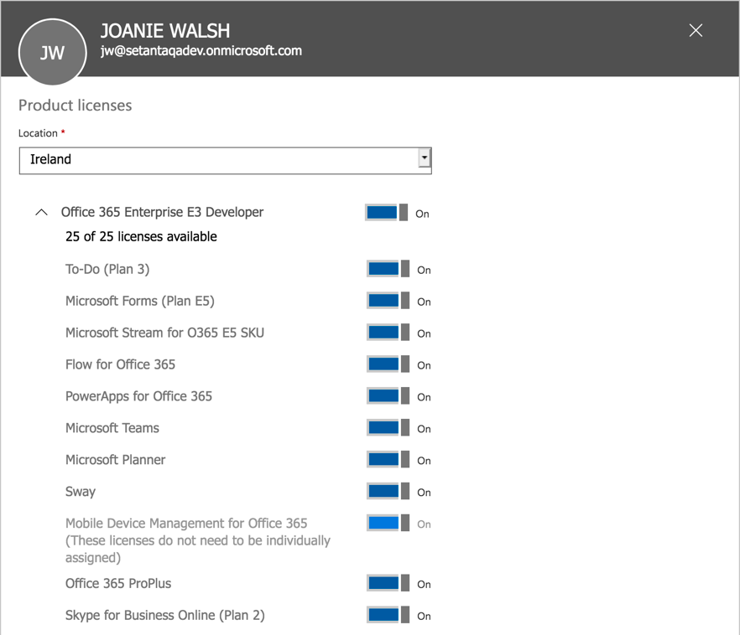

Verify that Office 365 is now displayed as an assigned product and click Close.
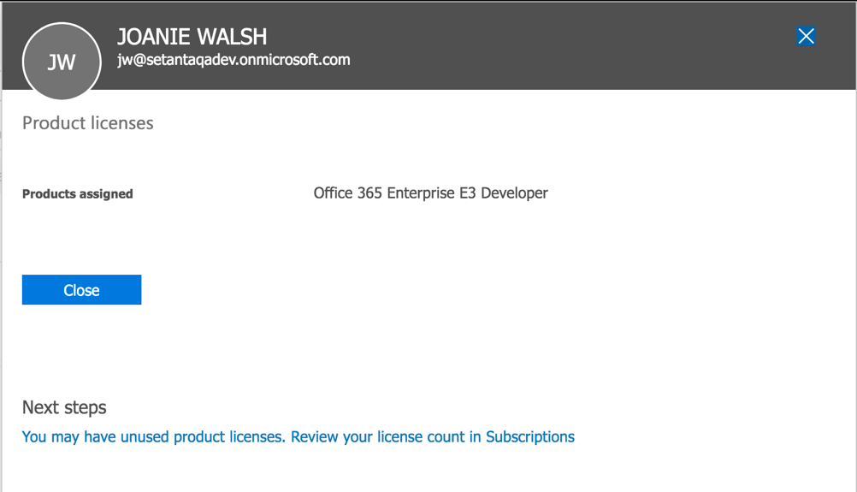

On your profile page, verify again that Office 365 is displayed as a product license and close.
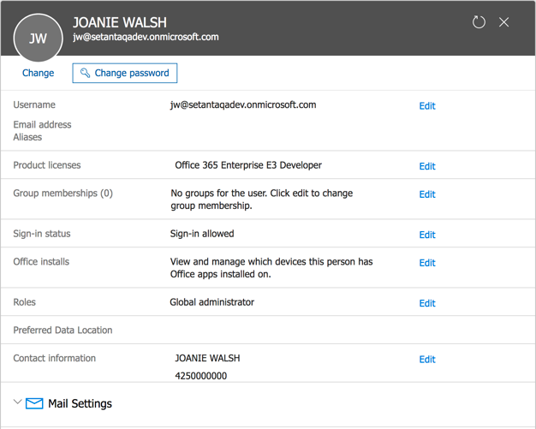
On the Office 365 page, refresh your browser – you should now see a range of apps starting with Outlook.
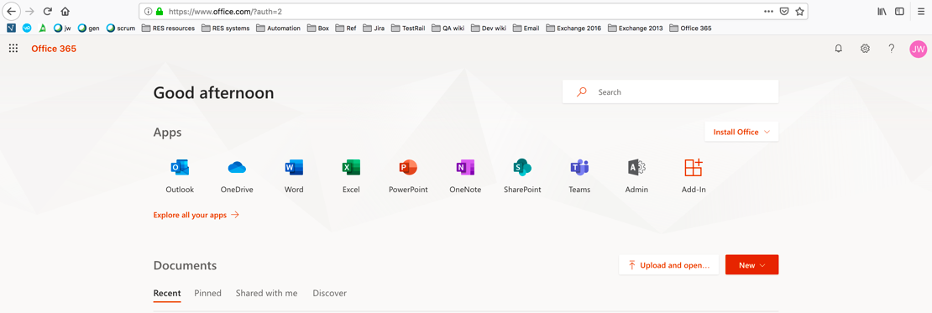

Not sure how I got from the page above to the page below?
Or if I even needed to go to the page below and sign in again – according to my notes, next thing I did was click on Outlook.

Click on office.com

Enter with office365 credentials
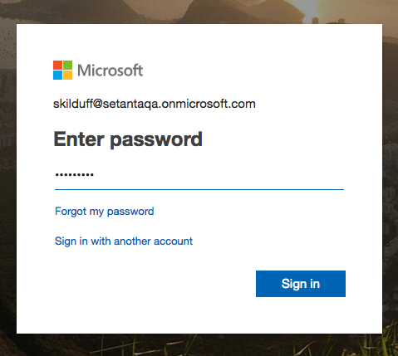

Click on Outlook
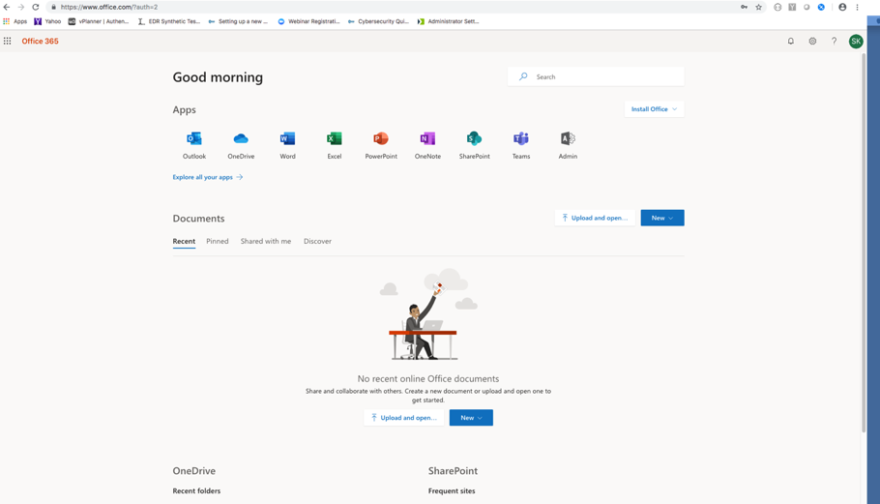

On the Outlook landing page, specify language and time zone.
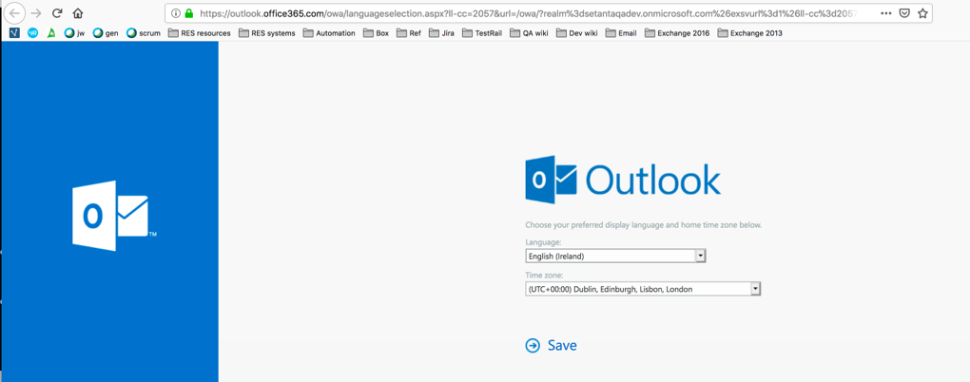

Folders are displayed
